Themes from US census

Surveys & Programs

1. Estimated Monthly Sales for Retail and Food Services, by Kind of Business: (absolute sale value, percent change, median standard error for percent change)

Retail & food services: total, Total (excl. motor vehicle & parts), Total (excl. gasoline stations),Total (excl. motor vehicle & parts & gasoline stations, Retail

GAFO: GAFO represents firms which specialize in department store types of merchandise and is comprised of furniture & home furnishings (442), electronics & appliances (443)

Motor vehicle & parts dealers:Auto & other motor veh. Dealers, New car dealers, Auto parts, acc. & tire stores

Furniture & home furn. Stores: Furniture stores, Home furnishings stores

Electronics & appliance stores

Building material & garden eq. & supplies dealers: Building mat. & sup. dealers

Food & beverage stores: Grocery stores, Beer, wine & liquor stores

Health & personal care stores: Pharmacies & drug stores

Gasoline stations

Clothing & clothing accessories stores: Men's clothing stores, Women's clothing stores, Family clothing stores, Shoe stores

Sporting goods, hobby, musical instrument, & book stores

General merchandise stores: Department stores, Other general merch. Stores, Warehouse clubs & supercenters, All oth. gen. merch. Stores

Miscellaneous store retailers

Nonstore retailers: Elect. shopping & m/o houses

Food services & drinking places

1. The [American Community Survey](https://www.census.gov/programs-surveys/acs/about.html) (ACS) helps local officials, community leaders, and businesses understand the changes taking place in their communities. It is the premier source for detailed population and housing information about our nation.

ACSDP1Y2018.csv file

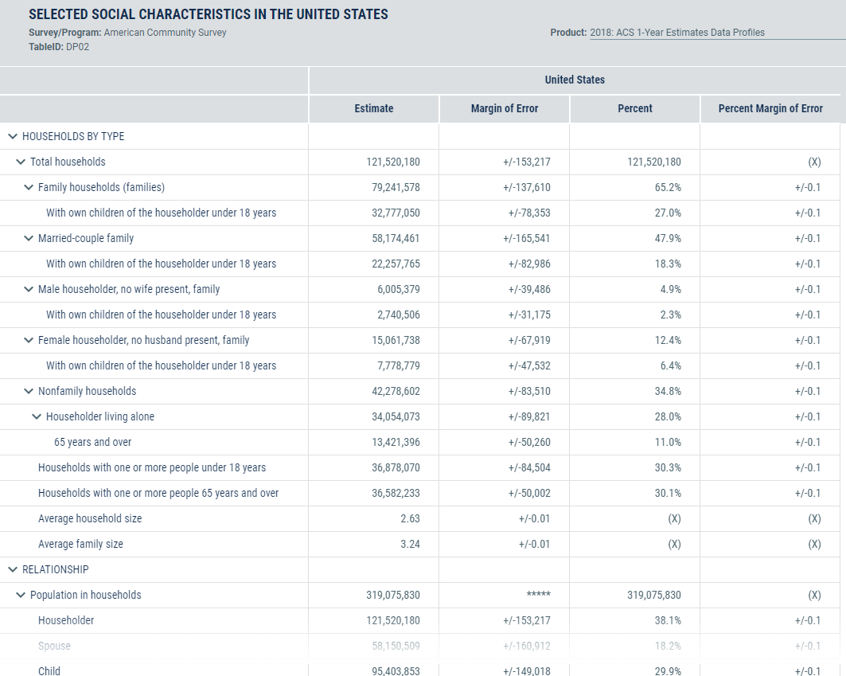

1. American Housing Survey (AHS)

The AHS is sponsored by the Department of Housing and Urban Development (HUD) and conducted by the U.S. Census Bureau. The survey is the most comprehensive national housing survey in the United States.

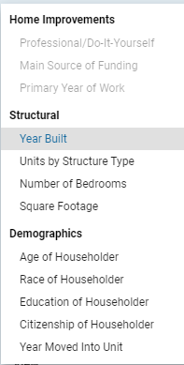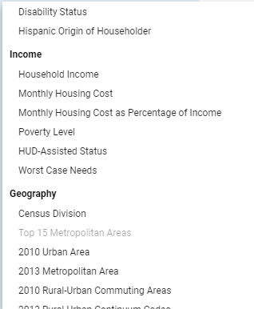

1. The American Time Use Survey (ATUS) measures the amount of time people spend doing various activities, such as paid work, childcare, volunteering, and socializing.

Time spent in detailed primary activities and percent of the civilian population engaging in each activity, averages per day

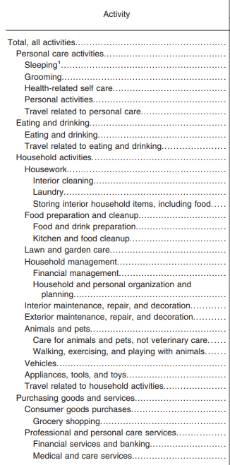

1. Annual Capital Expenditures Survey (ACES). The Annual Capital Expenditures Survey (ACES) provides data on capital spending for new and used structures and equipment by U.S. nonfarm businesses with and without employees.

Capital expenditures for new/used structures/equipment for all companies/companies with employees

1. Annual Survey of Entrepreneurs (ASE) - U.S. Exporting Firms

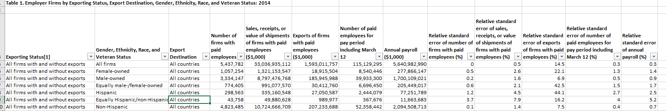

1. Annual Survey of Manufactures (ASM): The Annual Survey of Manufactures (ASM) provides sample estimates of statistics for all manufacturing establishments with one or more paid employee.

|  |  |  |  |  |  |  |  |  |  |  |  |  |  |  |  |  |  |
| --- | --- | --- | --- | --- | --- | --- | --- | --- | --- | --- | --- | --- | --- | --- | --- | --- | --- |
| Number of employees | Relative standard error for estimate of number of employees (%) | Annual payroll ($1,000) | Relative standard error for estimate of annual payroll (%) | Production workers average for year | Relative standard error for estimate of production workers average for year (%) | Production workers annual hours (1,000) | Relative standard error for estimate of production workers annual hours (%) | Production workers annual wages ($1,000) | Relative standard error for estimate of production workers annual wages (%) | Total cost of materials ($1,000) | Relative standard error for estimate of total cost of materials (%) | Total value of shipments and receipts for services ($1,000) | Relative standard error for estimate of total value of shipments and receipts for services (%) | Value added ($1,000) | Relative standard error for estimate of value added (%) | Total capital expenditures (new and used) ($1,000) | Relative standard error of total capital expenditures (new and used) (%) |
| Manufacturing | | | | | | | | | | | | | | | | | |
| Food manufacturing | | | | | | | | | | | | | | | | | |
| Animal food manufacturing | | | | | | | | | | | | | | | | | |
| Grain and oilseed milling | | | | | | | | | | | | | | | | | |
| Sugar and confectionery product manufacturing | | | | | | | | | | | | | | | | | |
| Fruit and vegetable preserving and specialty food manufacturing | | | | | | | | | | | | | | | | | |
| Dairy product manufacturing | | | | | | | | | | | | | | | | | |
| Animal slaughtering and processing | | | | | | | | | | | | | | | | | |
| Seafood product preparation and packaging | | | | | | | | | | | | | | | | | |
| Bakeries and tortilla manufacturing | | | | | | | | | | | | | | | | | |
| Other food manufacturing | | | | | | | | | | | | | | | | | |
| Beverage and tobacco product manufacturing | | | | | | | | | | | | | | | | | |
| Beverage manufacturing | | | | | | | | | | | | | | | | | |
| Tobacco manufacturing | | | | | | | | | | | | | | | | | |
| Textile mills | | | | | | | | | | | | | | | | | |
| Fiber, yarn, and thread mills | | | | | | | | | | | | | | | | | |
| Fabric mills | | | | | | | | | | | | | | | | | |
| Textile and fabric finishing and fabric coating mills | | | | | | | | | | | | | | | | | |
| Textile product mills | | | | | | | | | | | | | | | | | |
| Textile furnishings mills | | | | | | | | | | | | | | | | | |
| Other textile product mills | | | | | | | | | | | | | | | | | |
| Apparel manufacturing | | | | | | | | | | | | | | | | | |
| Apparel knitting mills | | | | | | | | | | | | | | | | | |
| Cut and sew apparel manufacturing | | | | | | | | | | | | | | | | | |
| Apparel accessories and other apparel manufacturing | | | | | | | | | | | | | | | | | |
| Leather and allied product manufacturing | | | | | | | | | | | | | | | | | |
| Leather and hide tanning and finishing | | | | | | | | | | | | | | | | | |
| Footwear manufacturing | | | | | | | | | | | | | | | | | |
| Other leather and allied product manufacturing | | | | | | | | | | | | | | | | | |
| Wood product manufacturing | | | | | | | | | | | | | | | | | |
| Sawmills and wood preservation | | | | | | | | | | | | | | | | | |
| Veneer, plywood, and engineered wood product manufacturing | | | | | | | | | | | | | | | | | |
| Other wood product manufacturing | | | | | | | | | | | | | | | | | |
| Paper manufacturing | | | | | | | | | | | | | | | | | |
| Pulp, paper, and paperboard mills | | | | | | | | | | | | | | | | | |
| Converted paper product manufacturing | | | | | | | | | | | | | | | | | |
| Printing and related support activities | | | | | | | | | | | | | | | | | |
| Printing and related support activities | | | | | | | | | | | | | | | | | |
| Petroleum and coal products manufacturing | | | | | | | | | | | | | | | | | |
| Petroleum and coal products manufacturing | | | | | | | | | | | | | | | | | |
| Chemical manufacturing | | | | | | | | | | | | | | | | | |
| Basic chemical manufacturing | | | | | | | | | | | | | | | | | |
| Resin, synthetic rubber, and artificial synthetic fibers and filaments manufacturing | | | | | | | | | | | | | | | | | |
| Pesticide, fertilizer, and other agricultural chemical manufacturing | | | | | | | | | | | | | | | | | |
| Pharmaceutical and medicine manufacturing | | | | | | | | | | | | | | | | | |
| Paint, coating, and adhesive manufacturing | | | | | | | | | | | | | | | | | |
| Soap, cleaning compound, and toilet preparation manufacturing | | | | | | | | | | | | | | | | | |
| Other chemical product and preparation manufacturing | | | | | | | | | | | | | | | | | |
| Plastics and rubber products manufacturing | | | | | | | | | | | | | | | | | |
| Plastics product manufacturing | | | | | | | | | | | | | | | | | |
| Rubber product manufacturing | | | | | | | | | | | | | | | | | |
| Nonmetallic mineral product manufacturing | | | | | | | | | | | | | | | | | |
| Clay product and refractory manufacturing | | | | | | | | | | | | | | | | | |
| Glass and glass product manufacturing | | | | | | | | | | | | | | | | | |
| Cement and concrete product manufacturing | | | | | | | | | | | | | | | | | |
| Lime and gypsum product manufacturing | | | | | | | | | | | | | | | | | |
| Other nonmetallic mineral product manufacturing | | | | | | | | | | | | | | | | | |
| Primary metal manufacturing | | | | | | | | | | | | | | | | | |
| Iron and steel mills and ferroalloy manufacturing | | | | | | | | | | | | | | | | | |
| Steel product manufacturing from purchased steel | | | | | | | | | | | | | | | | | |
| Alumina and aluminum production and processing | | | | | | | | | | | | | | | | | |
| Nonferrous metal (except aluminum) production and processing | | | | | | | | | | | | | | | | | |
| Foundries | | | | | | | | | | | | | | | | | |
| Fabricated metal product manufacturing | | | | | | | | | | | | | | | | | |
| Forging and stamping | | | | | | | | | | | | | | | | | |
| Cutlery and handtool manufacturing | | | | | | | | | | | | | | | | | |
| Architectural and structural metals manufacturing | | | | | | | | | | | | | | | | | |
| Boiler, tank, and shipping container manufacturing | | | | | | | | | | | | | | | | | |
| Hardware manufacturing | | | | | | | | | | | | | | | | | |
| Spring and wire product manufacturing | | | | | | | | | | | | | | | | | |
| Machine shops; turned product; and screw, nut, and bolt manufacturing | | | | | | | | | | | | | | | | | |
| Coating, engraving, heat treating, and allied activities | | | | | | | | | | | | | | | | | |
| Other fabricated metal product manufacturing | | | | | | | | | | | | | | | | | |
| Machinery manufacturing | | | | | | | | | | | | | | | | | |
| Agriculture, construction, and mining machinery manufacturing | | | | | | | | | | | | | | | | | |
| Industrial machinery manufacturing | | | | | | | | | | | | | | | | | |
| Commercial and service industry machinery manufacturing | | | | | | | | | | | | | | | | | |
| Ventilation, heating, air-conditioning, and commercial refrigeration equipment manufacturing | | | | | | | | | | | | | | | | | |
| Metalworking machinery manufacturing | | | | | | | | | | | | | | | | | |
| Engine, turbine, and power transmission equipment manufacturing | | | | | | | | | | | | | | | | | |
| Other general purpose machinery manufacturing | | | | | | | | | | | | | | | | | |
| Computer and electronic product manufacturing | | | | | | | | | | | | | | | | | |
| Computer and peripheral equipment manufacturing | | | | | | | | | | | | | | | | | |
| Communications equipment manufacturing | | | | | | | | | | | | | | | | | |
| Audio and video equipment manufacturing | | | | | | | | | | | | | | | | | |
| Semiconductor and other electronic component manufacturing | | | | | | | | | | | | | | | | | |
| Navigational, measuring, electromedical, and control instruments manufacturing | | | | | | | | | | | | | | | | | |
| Manufacturing and reproducing magnetic and optical media | | | | | | | | | | | | | | | | | |
| Electrical equipment, appliance, and component manufacturing | | | | | | | | | | | | | | | | | |
| Electric lighting equipment manufacturing | | | | | | | | | | | | | | | | | |
| Household appliance manufacturing | | | | | | | | | | | | | | | | | |
| Electrical equipment manufacturing | | | | | | | | | | | | | | | | | |
| Other electrical equipment and component manufacturing | | | | | | | | | | | | | | | | | |
| Transportation equipment manufacturing | | | | | | | | | | | | | | | | | |
| Motor vehicle manufacturing | | | | | | | | | | | | | | | | | |
| Motor vehicle body and trailer manufacturing | | | | | | | | | | | | | | | | | |
| Motor vehicle parts manufacturing | | | | | | | | | | | | | | | | | |
| Aerospace product and parts manufacturing | | | | | | | | | | | | | | | | | |
| Railroad rolling stock manufacturing | | | | | | | | | | | | | | | | | |
| Ship and boat building | | | | | | | | | | | | | | | | | |
| Other transportation equipment manufacturing | | | | | | | | | | | | | | | | | |
| Furniture and related product manufacturing | | | | | | | | | | | | | | | | | |
| Household and institutional furniture and kitchen cabinet manufacturing | | | | | | | | | | | | | | | | | |
| Office furniture (including fixtures) manufacturing | | | | | | | | | | | | | | | | | |
| Other furniture related product manufacturing | | | | | | | | | | | | | | | | | |
| Miscellaneous manufacturing | | | | | | | | | | | | | | | | | |
| Medical equipment and supplies manufacturing | | | | | | | | | | | | | | | | | |
| Other miscellaneous manufacturing | | | | | | | | | | | | | | | | | |

1. Annual Survey of School System Finances

Education finance data include revenues, expenditures, debt, and assets [cash and security holdings] of elementary and secondary public school systems. Statistics cover school systems in all states, and include the District of Columbia.

|  |  |  |  |  |  |  |  |  |  |
| --- | --- | --- | --- | --- | --- | --- | --- | --- | --- |
| Elementary-secondary revenue 1 | | | | Elementary-secondary expenditure 1 | | | | Debt |  |
|  |  |  |  |  |  |  |  | outstanding |  |
|  | From federal | From state | From local |  | Current | Capital |  | at end of | Cash and |
| Total | sources | sources | sources | Total | spending | outlay | Other 2 | fiscal year | securities |
|  |  |  |  |  |  |  |  |  |  |
| 694,111,263 | 55,292,242 | 327,082,099 | 311,736,922 | 694,235,498 | 610,301,022 | 62,784,988 | 21,149,488 | 452,120,068 | 245,061,568 |
|  |  |  |  |  |  |  |  |  |  |

Revenue from State Sources for Public Elementary-Secondary School Systems by State:

|  |  |  |  |  |  |  |  |  |  |  |  |  |  |  |  |
| --- | --- | --- | --- | --- | --- | --- | --- | --- | --- | --- | --- | --- | --- | --- | --- |
|  | | General | |  | |  | |  | |  | | Other and | | State | |
|  | | formula | | Compensatory | | Special | | Vocational | | Transportation | | nonspecified | | payments on | |
| Total | | assistance | | programs | | education | | programs | | programs | | state aid 1 | | behalf of LEA | |
|  |  | |  | |  | |  | |  | |  | |  | |  | |
| 327,082,099 | | 223,746,827 | | 5,170,447 | | 20,639,290 | | 1,224,308 | | 4,077,175 | | 51,180,955 | | 21,043,097 | |

**Revenue from Local Sources for Public Elementary-Secondary School Systems by State:**

|  |  |  |  |  |  |  |  |  |
| --- | --- | --- | --- | --- | --- | --- | --- | --- |
|  |  |  | Parent | Nonschool |  | Tuition and |  |  |
|  | Property | Other | government | local | School lunch | transportation | Other | Other local |
| Total | taxes | taxes | contributions | government | charges | charges | charges 1 | revenue |
|  |  |  |  |  |  |  |  |  |
| 311,736,922 | 203,125,150 | 9,507,534 | 57,982,787 | 8,953,538 | 5,590,543 | 1,354,356 | 7,992,461 | 17,230,553 |

**Support Services Expenditure for Public Elementary-Secondary School Systems**

|  |  |  |  |  |  |  |  |
| --- | --- | --- | --- | --- | --- | --- | --- |
|  |  |  |  |  |  |  | Other and |
|  |  | Instructional |  |  | Operation and |  | nonspecified |
|  | Pupil support | staff | General | School | maintenance | Pupil | support |
| Total | services | support services | administration | administration | of plant | transportation | services |
|  |  |  |  |  |  |  |  |
| 208,731,153 | 34,837,317 | 28,116,925 | 11,205,301 | 32,763,200 | 54,840,352 | 25,225,038 | 21,743,020 |

1. [Annual Survey of State Government Finances](https://www.census.gov/programs-surveys/state.html)

|  |
| --- |
| Total revenue |
|  |
| General revenue |
| Intergovernmental revenue |
| Taxes |
| General sales |
| Selective sales |
| License taxes |
| Individual income tax |
| Corporate income tax |
| Other taxes |
|  |
| Current charge |
| Miscellaneous general revenue |
|  |
| Utility revenue |
| Liquor stores revenue |
| Insurance trust revenue |
|  |
| Total expenditure |
| Intergovernmental expenditure |
| Direct expenditure |
| Current operation |
| Capital outlay |
| Insurance benefits and repayments |
| Assistance and subsidies |
| Interest on debt |
| Exhibit: Salaries and wages |
|  |
| Total expenditure |
| General expenditure |
| Intergovernmental expenditure |
| Direct expenditure |
|  |
| General expenditure, by function: |
| Education |
| Public welfare |
| Hospitals |
| Health |
| Highways |
|  |
| Police protection |
| Correction |
| Natural resources |
| Parks and recreation |
| Governmental administration |
|  |
| Interest on general debt |
| Other and unallocable |
|  |
| Utility expenditure |
| Liquor stores expenditure |
| Insurance trust expenditure |
|  |
| Debt at end of fiscal year |
|  |
| Cash and security holdings |

1. Annual Survey of State Government Tax Collections (STC)

The Annual Survey of State Government Tax Collections (STC) provides a summary of taxes collected by state for 5 broad tax categories and up to 25 tax subcategories.

|  |
| --- |
| Total Taxes |
| Property Taxes |
| Sales and Gross Receipts Taxes |
| License Taxes |
| Income Taxes |
| Other Taxes |